HAMNA ALIM  
22F-3166

QUESTION NO 01

MAIN ACTIVITY CODE

package com.example.ecommerceapp;

import android.os.Bundle;

import android.widget.ListView;

import androidx.appcompat.app.AppCompatActivity;

import java.util.ArrayList;

import java.util.List;

public class MainActivity extends AppCompatActivity {

private ListView productListView;

private ProductAdapter productAdapter;

private List<Product> productList;

@Override

protected void onCreate(Bundle savedInstanceState) {

super.onCreate(savedInstanceState);

setContentView(R.layout.*activity_main*);

productListView = findViewById(R.id.*productListView*);

*// Initialize product list*

productList = new ArrayList<>();

loadSampleProducts(); *// Load dummy data*

*// Set up the adapter*

productAdapter = new ProductAdapter(this, productList);

productListView.setAdapter(productAdapter);

}

private void loadSampleProducts() {

productList.add(new Product(R.drawable.*tv*, "Smart TV", "Samsung", 50000, 45000, 4.5f, 10));

productList.add(new Product(R.drawable.*laptop*, "Gaming Laptop", "Dell", 80000, 72000, 4.7f, 10));

productList.add(new Product(R.drawable.*iphone*, "iPhone 14", "Apple", 90000, 85000, 4.8f, 5));

productList.add(new Product(R.drawable.*tripod*, "Camera Tripod", "Sony", 5000, 4500, 4.3f, 10));

productList.add(new Product(R.drawable.*camera*, "DSLR Camera", "Canon", 60000, 54000, 4.6f, 10));

}

}

PRODUCT.java CODE

package com.example.ecommerceapp;

public class Product {

private int imageResId;

private String title;

private String brand;

private double originalPrice;

private double discountedPrice;

private float rating;

private int discountPercentage;

public Product(int imageResId, String title, String brand, double originalPrice, double discountedPrice, float rating, int discountPercentage) {

this.imageResId = imageResId;

this.title = title;

this.brand = brand;

this.originalPrice = originalPrice;

this.discountedPrice = discountedPrice;

this.rating = rating;

this.discountPercentage = discountPercentage;

}

public int getImageResId() { return imageResId; }

public String getTitle() { return title; }

public String getBrand() { return brand; }

public double getOriginalPrice() { return originalPrice; }

public double getDiscountedPrice() { return discountedPrice; }

public float getRating() { return rating; }

public int getDiscountPercentage() { return discountPercentage; }

}

PRODUCTADAPTER.java

package com.example.ecommerceapp;

import android.content.Context;

import android.graphics.Paint;

import android.view.LayoutInflater;

import android.view.View;

import android.view.ViewGroup;

import android.widget.BaseAdapter;

import android.widget.ImageView;

import android.widget.RatingBar;

import android.widget.TextView;

import java.util.List;

public class ProductAdapter extends BaseAdapter {

private Context context;

private List<Product> productList;

public ProductAdapter(Context context, List<Product> productList) {

this.context = context;

this.productList = productList;

}

@Override

public int getCount() {

return productList.size();

}

@Override

public Object getItem(int position) {

return productList.get(position);

}

@Override

public long getItemId(int position) {

return position;

}

@Override

public View getView(int position, View convertView, ViewGroup parent) {

ViewHolder holder;

if (convertView == null) {

convertView = LayoutInflater.from(context).inflate(R.layout.product_item, parent, false);

holder = new ViewHolder();

holder.productImage = convertView.findViewById(R.id.productImage);

holder.productTitle = convertView.findViewById(R.id.productTitle);

holder.productBrand = convertView.findViewById(R.id.productBrand);

holder.originalPrice = convertView.findViewById(R.id.originalPrice);

holder.discountedPrice = convertView.findViewById(R.id.discountedPrice);

holder.discountTag = convertView.findViewById(R.id.discountTag);

holder.ratingBar = convertView.findViewById(R.id.productRating);

convertView.setTag(holder);

} else {

holder = (ViewHolder) convertView.getTag();

}

// Get current product

Product product = productList.get(position);

// Set data

holder.productImage.setImageResource(product.getImageResId());

holder.productTitle.setText(product.getTitle());

holder.productBrand.setText(product.getBrand());

holder.originalPrice.setText("$" + product.getOriginalPrice());

holder.discountedPrice.setText("$" + product.getDiscountedPrice());

holder.discountTag.setText("-" + product.getDiscountPercentage() + "%");

holder.ratingBar.setRating(product.getRating());

// Apply Strike-through Effect for Original Price

holder.originalPrice.setPaintFlags(holder.originalPrice.getPaintFlags() | Paint.STRIKE_THRU_TEXT_FLAG);

return convertView;

}

static class ViewHolder {

ImageView productImage;

TextView productTitle;

TextView productBrand;

TextView originalPrice;

TextView discountedPrice;

TextView discountTag;

RatingBar ratingBar;

}

}

PRODUCT_ITEM.XML code

\<LinearLayout xmlns:android="http://schemas.android.com/apk/res/android"

android:layout_width="match_parent"

android:layout_height="wrap_content"

android:orientation="vertical"

android:padding="8dp"

android:background="@android:color/white">

*<!-- Product Image -->*

<ImageView

android:id="@+id/productImage"

android:layout_width="match_parent"

android:layout_height="200dp"

android:scaleType="centerCrop"

android:src="@drawable/camera"/>

*<!-- Product Info -->*

<LinearLayout

android:layout_width="match_parent"

android:layout_height="wrap_content"

android:orientation="vertical"

android:padding="8dp">

<TextView

android:id="@+id/productTitle"

android:layout_width="wrap_content"

android:layout_height="wrap_content"

android:text="Camera"

android:textSize="16sp"

android:textStyle="bold" />

<TextView

android:id="@+id/productBrand"

android:layout_width="wrap_content"

android:layout_height="wrap_content"

android:text="Nikon"

android:textSize="14sp" />

<TextView

android:id="@+id/discountTag"

android:layout_width="wrap_content"

android:layout_height="wrap_content"

android:text="@string/_20"

android:textColor="@android:color/holo_red_dark"

android:textStyle="bold"/>

<TextView

android:id="@+id/originalPrice"

android:layout_width="wrap_content"

android:layout_height="wrap_content"

android:text="@string/_999_99"

android:textSize="14sp"

android:textColor="@android:color/darker_gray"

/>

<TextView

android:id="@+id/discountedPrice"

android:layout_width="wrap_content"

android:layout_height="wrap_content"

android:text="@string/_799_99"

android:textSize="16sp"

android:textStyle="bold"

android:textColor="@android:color/holo_green_dark"/>

<RatingBar

android:id="@+id/productRating"

android:layout_width="wrap_content"

android:layout_height="wrap_content"

android:numStars="5"

android:rating="4.5"

android:stepSize="0.5"/>

</LinearLayout>

</LinearLayout>

MAINACTIVITY.xml CODE  
<LinearLayout xmlns:android="http://schemas.android.com/apk/res/android"

android:layout_width="match_parent"

android:layout_height="match_parent"

android:orientation="vertical"

android:padding="8dp">

*<!-- Top Bar -->*

<RelativeLayout

android:layout_width="match_parent"

android:layout_height="56dp"

android:background="#6200EE"

android:padding="8dp">

<TextView

android:id="@+id/appTitle"

android:layout_width="wrap_content"

android:layout_height="wrap_content"

android:text="@string/a_mart"

android:textColor="@android:color/white"

android:textSize="20sp"

android:textStyle="bold"

android:layout_centerVertical="true"/>

<ImageView

android:id="@+id/cartIcon"

android:layout_width="24dp"

android:layout_height="24dp"

android:src="@drawable/ic_cart"

android:layout_alignParentEnd="true"/>

</RelativeLayout>

*<!-- Product List -->*

<ListView

android:id="@+id/productListView"

android:layout_width="match_parent"

android:layout_height="match_parent"

android:divider="@null"

android:dividerHeight="0dp"/>

</LinearLayout>

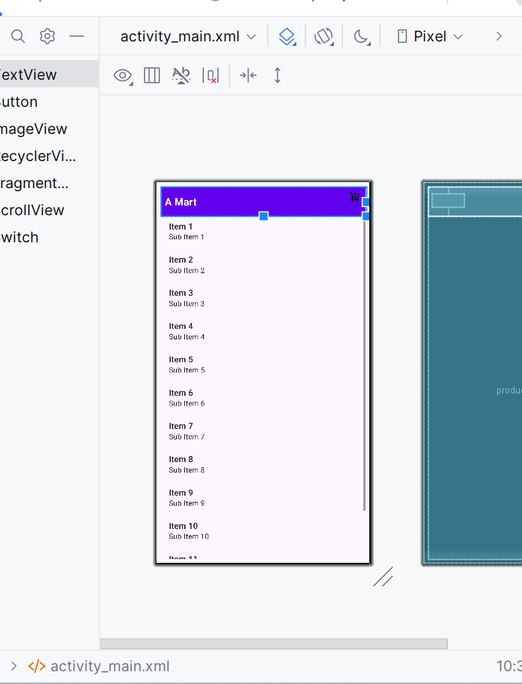

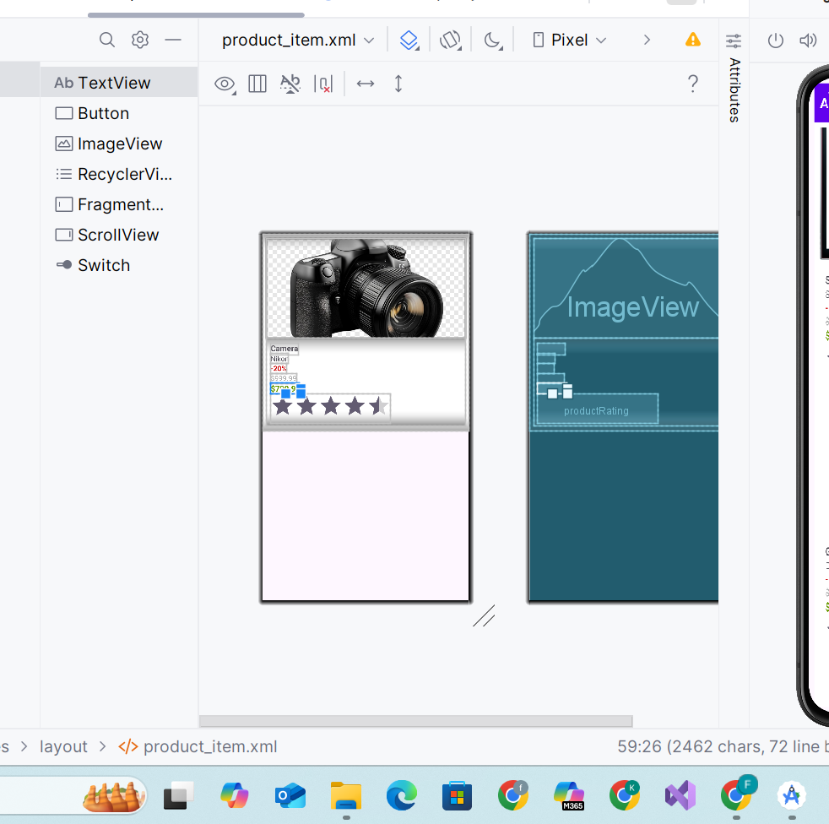

**QUESTION NO 02**